**PROJECT REPORT**

Amazon Sales Dashboard Analysis

**Name** – Abhishek Satpute

**Project Title** – Sales Dashboard Analysis

**Date** – 20 Jan 2025

**Technology** – Tableau

**Project Description:**

The Amazon Sales Dashboard provides insights into key performance metric for Amazon’s sales data, helping stakeholders analyze and understand business performance across regions, channels, and years. It leverages various visualizations to highlight trends in profit, revenue, shipment days, and order priorities. The dashboard visualizes sales, cost, profit, and order distribution across product categories for Amazon's business. The purpose is to derive insights into key performing categories and identify areas for improvement to enhance profitability and optimize operations.

**Objective:**

The main objectives of the project are:

* To evaluate regional and channel-wise profitability and revenue.
* To analyze trends in orders, shipping times, and costs over time.
* To identify areas of improvement to optimize operations and maximize profits.
* To analyze revenue, cost, and profit splits across various product categories.
* To evaluate order trends and highlight key contributors.
* To identify opportunities for optimization in product categories.
* To make data-driven recommendations for strategic decision-making.

**Key Performance Indicators (KPIs):**

* **Total Profit:** $797M
* **Total Revenue:** $2,409.7M
* **Average Shipment Days:** 24.31 days
* **Units Sold:** 9.1M

### **Data Summary:**

The dashboard consolidates Amazon’s sales data, broken down into:

* **Regions and Countries:** Highlighting Sub-Saharan Africa, Europe, and others.
* **Sales Channels:** Analyzing online and offline performance.
* **Order Priorities:** Distribution of orders by critical, high, medium, and low priority levels.
* **Yearly Trends:** Tracking orders, costs, and shipment days from 2010–2017.
* **Top Categories by Revenue**: Cosmetics ($724.38M), Office Supplies ($530.62M), Household ($469.81M).
* **Top Categories by Profit**: Cosmetics ($288.08M), Household ($116.51M), Office Supplies ($102.87M).
* **Top Categories by Orders**: Cosmetics (261 orders), Clothes (243 orders), Office Supplies (198 orders).
* **Least Performing Categories**: Fruits and Meat generate the least revenue, cost, profit, and orders.

#### **Analysis and findings:**

**a. Screenshot of Graph and Observations**

1. **Region wise Profits:**

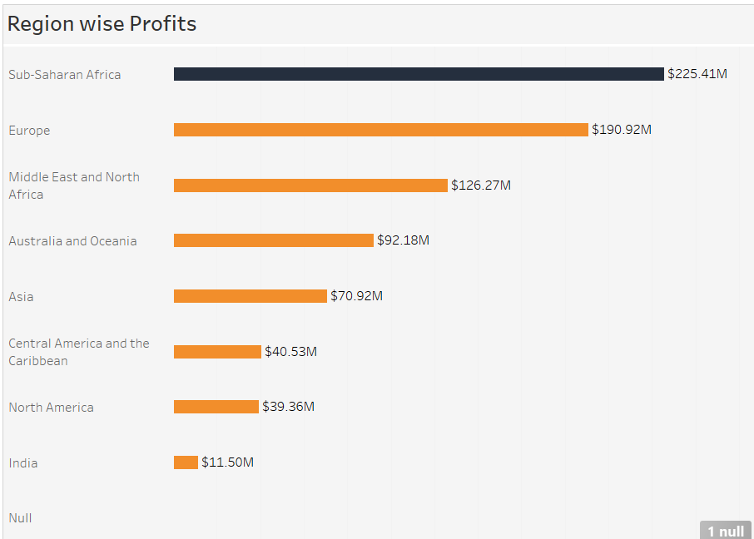

The horizontal bar graph illustrates the profit contribution from different regions.

* + Sub-Saharan Africa contributes the highest profit of $225.41M.
  + India has the lowest contribution at $11.50M.

1. **Country wise Profit:**

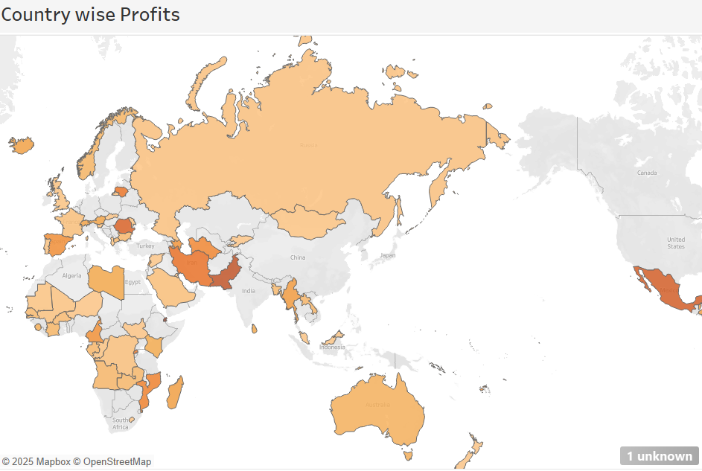

The map highlights country-specific profits with a color-coded scheme. Darker shades represent higher profits, while lighter shades indicate lower contributions.

* + Countries in Sub-Saharan Africa and Europe dominate in terms of darker shades, aligning with the region-wise profit insights.
  + India is a notable low-performer in profits, consistent with the bar graphs.

1. **Sales Channel Analysis:**

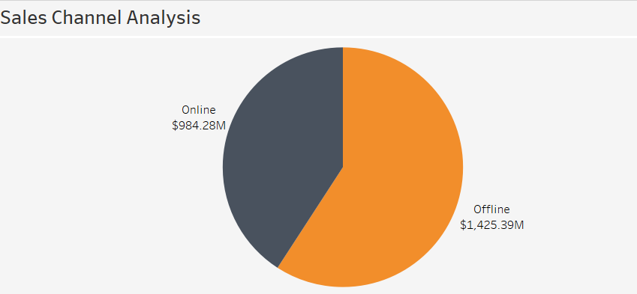

* Offline sales contribute significantly more than online sales, accounting for a larger share of the revenue.
* Despite the growing trend of online shopping, offline channels still dominate in this case. Strategies to boost online sales could enhance overall revenue.

1. **Orders per Year:**

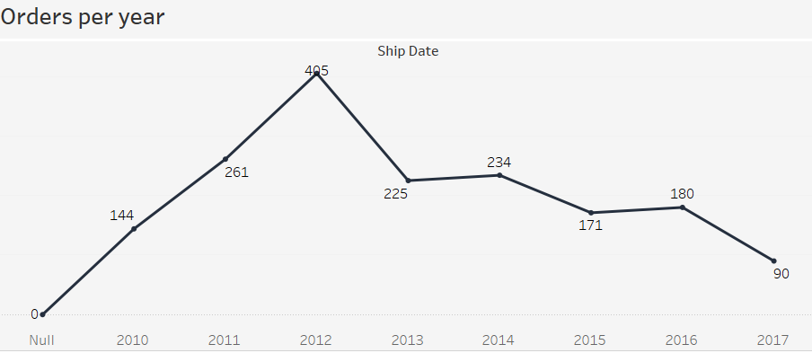

* After a rapid rise in orders from 2010 to 2012, the decline from 2013 onward indicates possible market saturation, reduced demand, or operational challenges.
* The sharp decline in 2017 to only 90 orders highlights a significant drop in performance that requires immediate investigation.

1. **Priority wise Orders:**

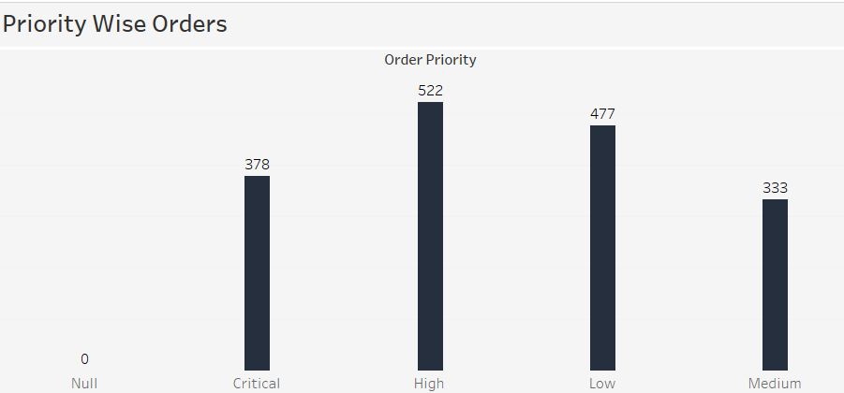

* High-priority orders dominate, suggesting customers or business demands prioritize quick fulfillment for a significant portion of transactions.
* Medium-priority orders are the lowest in volume, indicating either limited demand or prioritization strategies to focus on high/critical categories.

1. **Cost per Year:**

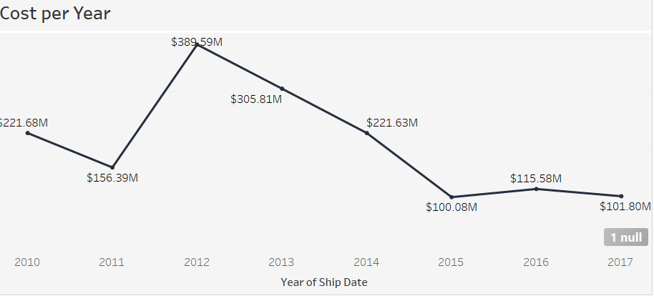

* Costs peaked in 2012, mirroring the rise in order volume. The subsequent decline aligns with reduced orders after 2013.
* Costs have stabilized around $100M in recent years, suggesting better cost management despite declining order volumes.

1. **Revenue and Shipment Days:**

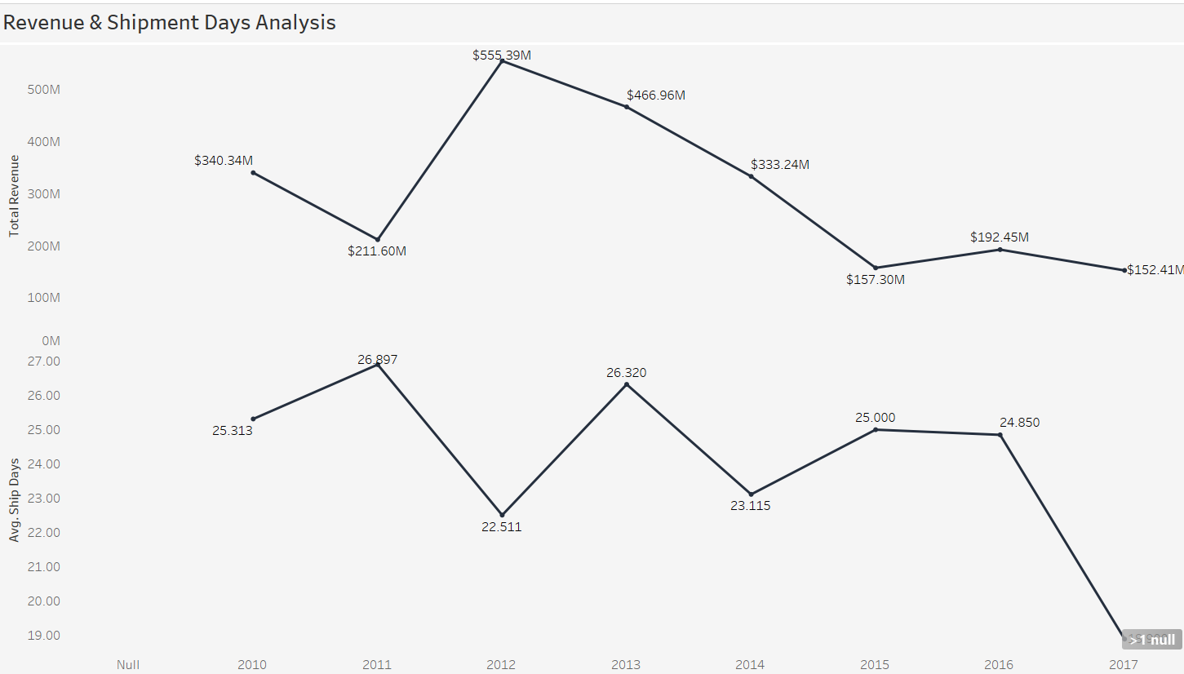

* + Revenue drops significantly with longer average shipment days.
  + The highest revenue was $555.39M in 2011, with an average shipment time of 26.897 days.

1. **Revenue and Cost Split**:

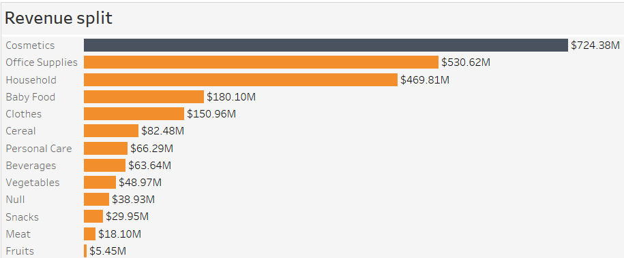

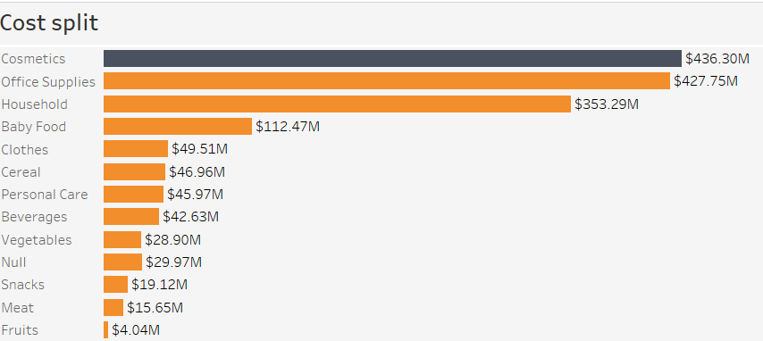

* Cosmetics, Office Supplies, and Household are the top 3 revenue generators, contributing significantly more than other categories.
* Cosmetics and Office Supplies also dominate the cost split, reflecting potentially higher product costs or operational expenses associated with these categories.

1. **Profit Split**:

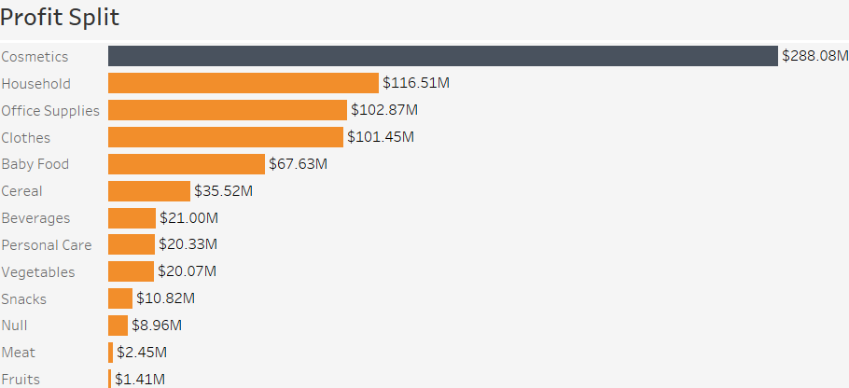

* Household, Office Supplies, and Clothes are the top 3 profit generators, highlighting their potential profitability.
* Baby Food, Cereal, and Beverages also show relatively high profit margins, demonstrating potentially successful pricing strategies.

1. **Orders Split**:

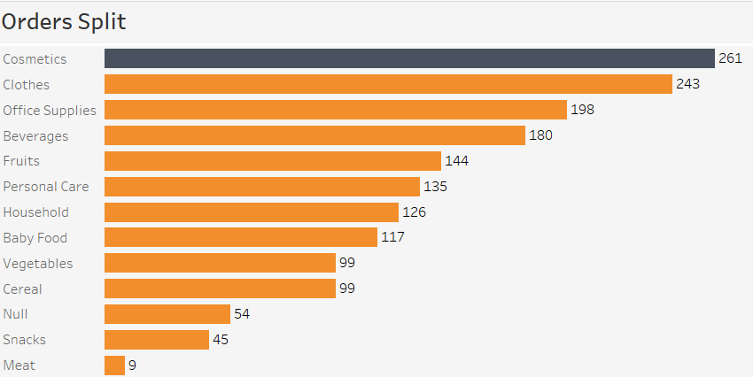

* Cosmetics and Clothes have the highest number of orders, suggesting high customer demand for these categories.
* Office Supplies, Beverages, and Fruits also receive a considerable number of orders, indicating their popularity among customers.

**Screenshot of Dashboard***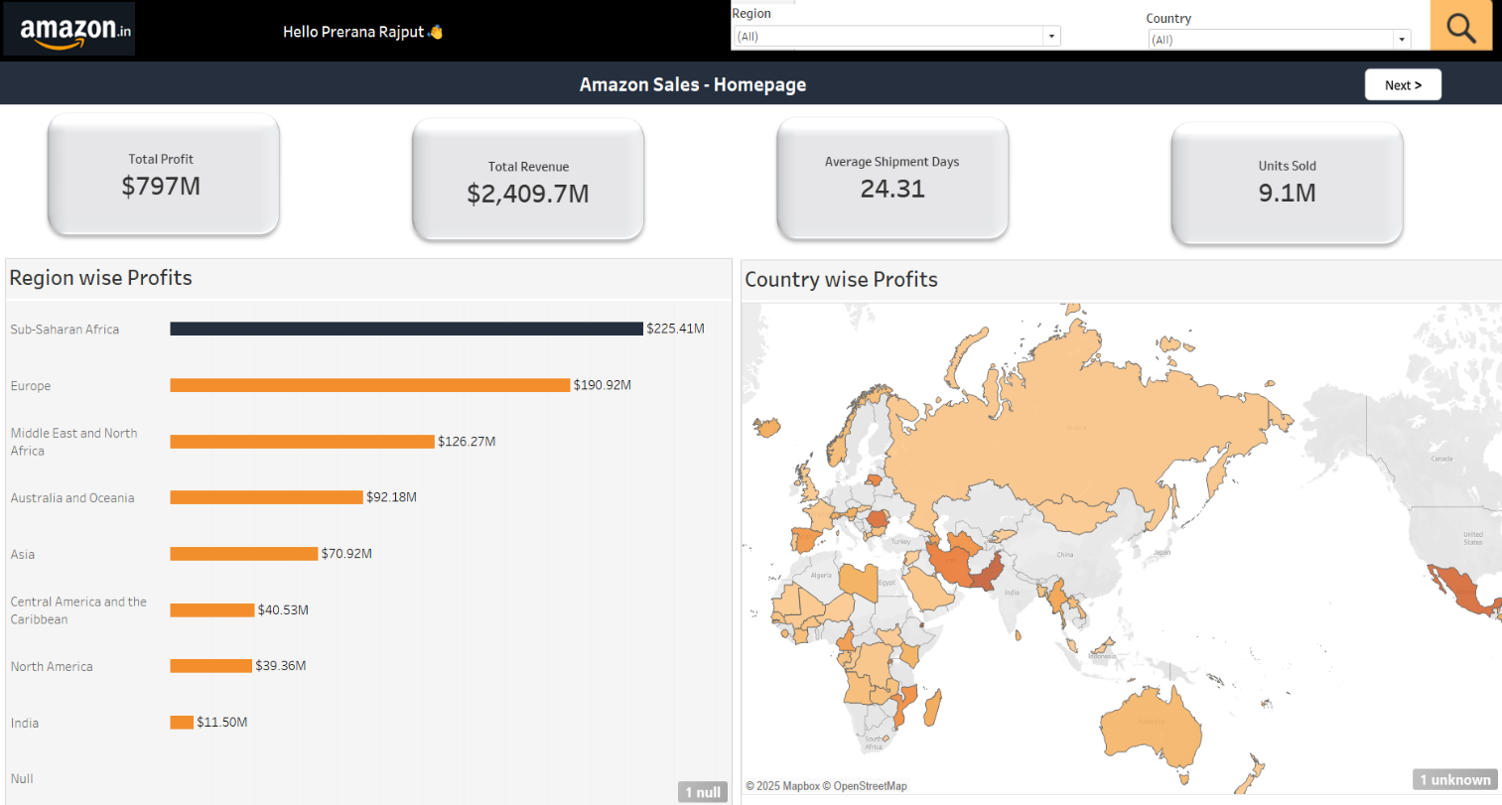*

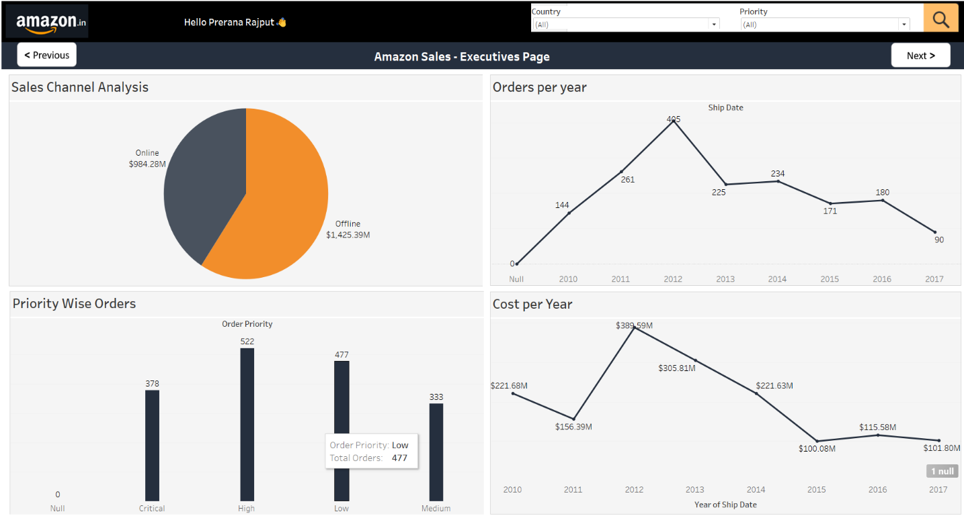

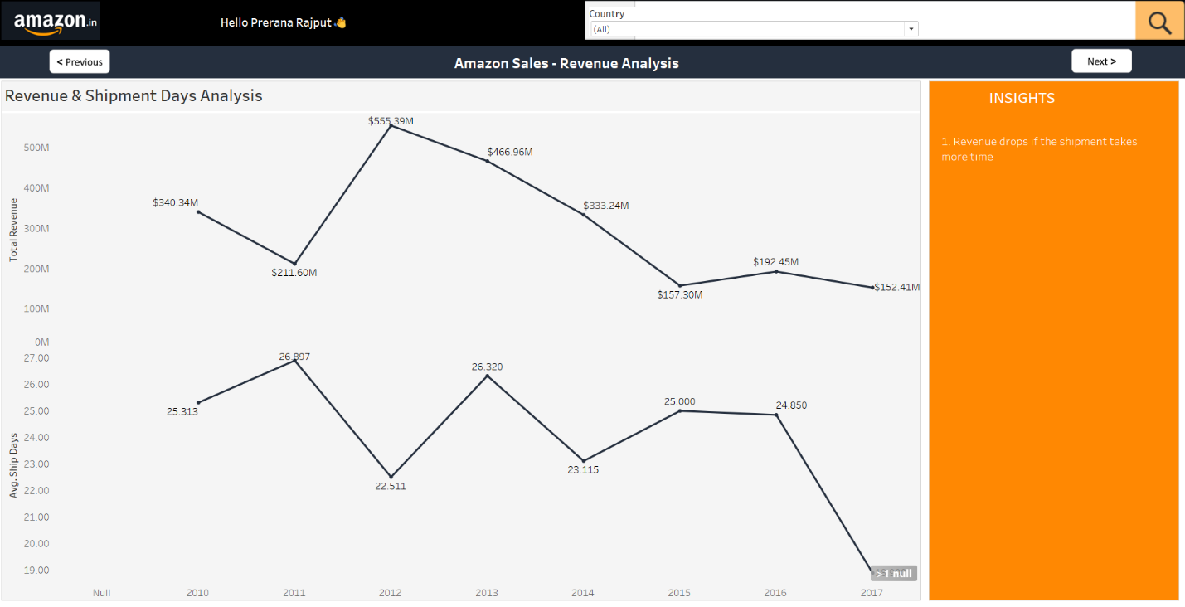

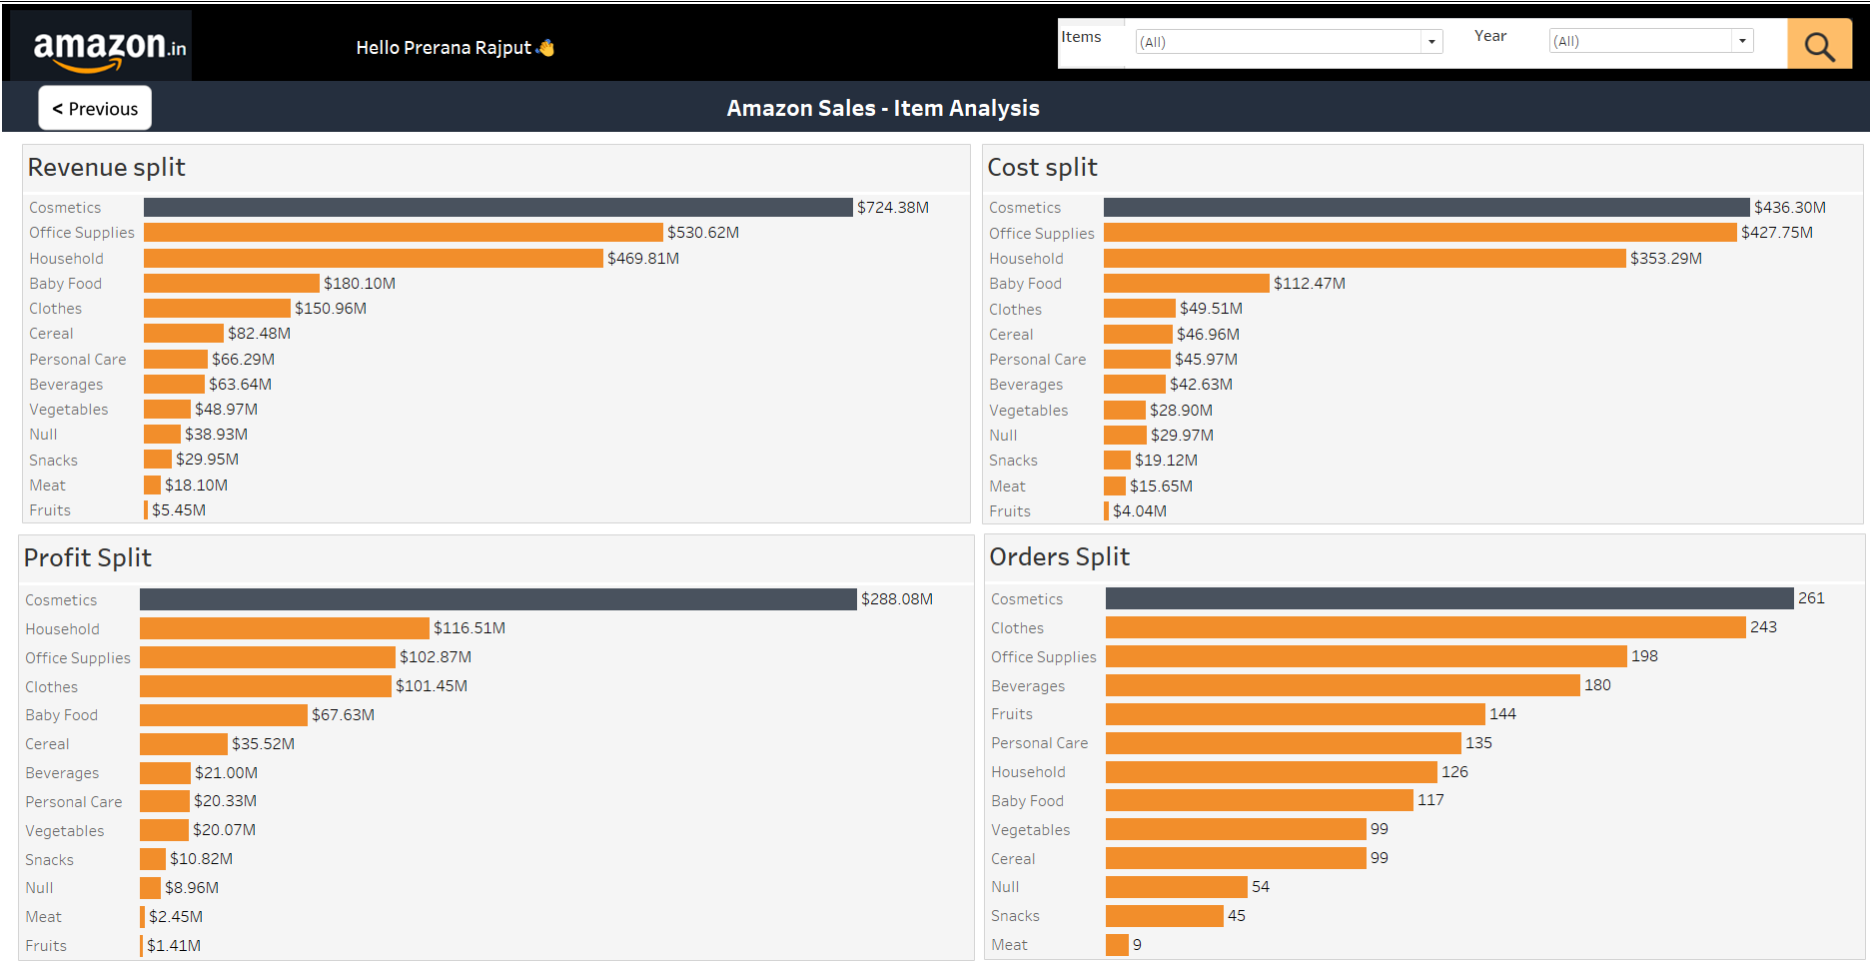

**Recommendations:**

* **Improve Shipment Times:** Focus on reducing average shipment days to under 20 days, as longer shipment times negatively impact revenue.
* **Boost Online Sales:** Develop strategies to narrow the gap between online and offline revenues, such as personalized recommendations and promotions.
* **Regional Focus:** Expand operations and marketing in regions with untapped potential, such as India, while continuing to strengthen top-performing regions like Sub-Saharan Africa and Europe.
* **Optimize Costs:** Analyze high-cost years (e.g., 2012) to identify and mitigate inefficiencies in operations.
* **Focus on High-Profit Categories**: Continue prioritizing Cosmetics, Household, and Office Supplies to maintain profitability.
* **Optimize Low-Performance Products**: Reassess the offerings in categories like Fruits and Meat, possibly by reducing inventory or marketing promotions to increase visibility.
* **Control Costs in High-Revenue Categories**: Investigate cost optimization strategies for Cosmetics and Office Supplies to boost margins further.
* **Expand Popular Categories** : Leverage strong order trends in Cosmetics and Clothes by introducing new products or bundles.

**Conclusion:**

The dashboard highlights critical insights into Amazon's sales performance, emphasizing the importance of regional focus, reducing shipment days, and balancing channel performance. By acting on the recommendations, Amazon can achieve sustained growth and enhanced customer satisfaction. The dashboard effectively highlights the performance of different categories, with Cosmetics being the standout performer in all KPIs. Strategic efforts should target improving low-performing categories while maximizing the potential of high-performing ones to sustain growth and profitability.